2026 May FHEA Board Meeting
Codes and Standards Report
5/18/2026

- New Business
  - Codes and Standards Committee
    - Committee meeting 4/1/26.
    - 51 Members
    - Topics included:
      - Vegetation fire risk
      - Pillow speakers (new construction)
      - FGI outpatient guidelines
      - TJC Fire Drill requirements
      - Fire Dampers
      - Fire Plans
  - Joint Commission
    - SIG FGI Outpatient Guidelines
      - 31 March 2026
Case Number: 00204621 0326ECHAH6926-1
      - The following question was submitted:

We are seeking clarification regarding the applicability of the FGI Guidelines for Design and Construction of Outpatient Facilities in relation to Joint Commission accreditation expectations.
Many organizations operate hospital-based outpatient clinics that are classified as business occupancies. Within the State of Florida, the adopted regulatory framework incorporates the FGI Guidelines for Hospitals; however, the FGI Outpatient Guidelines have not been formally adopted at the state level.
Given this context, we would appreciate your guidance on the following:
Does The Joint Commission consider the FGI Outpatient Guidelines to be a requirement for accreditation in hospital-based outpatient settings, or are they viewed as a best practice resource?
      - The Joint Commission response:
Joint Commission's requirement is that healthcare facilities are designed and constructed to meet federal, state, and local building requirements. For most construction projects, this involves approval from State Health Departments for design and construction, and then accreditation based on federal requirements, such as NFPA. Since the State of Florida has it's own building code, as long as the State of Florida has approved the design and granted occupancy of the building, this would meet the intention of the requirement above for design and construction. FGI is used as a best practice resource since most states utilize some or most of the "Design and Construction of Hospital or Outpatient Facilities" building guidelines, and is not considered a requirement unless part of the state building code.
James Grana, Field Director Division of Healthcare Improvement, TJC

      - 2023 FBC – Building Code, 8th Edition: 469 Office Surgery Suite
      - 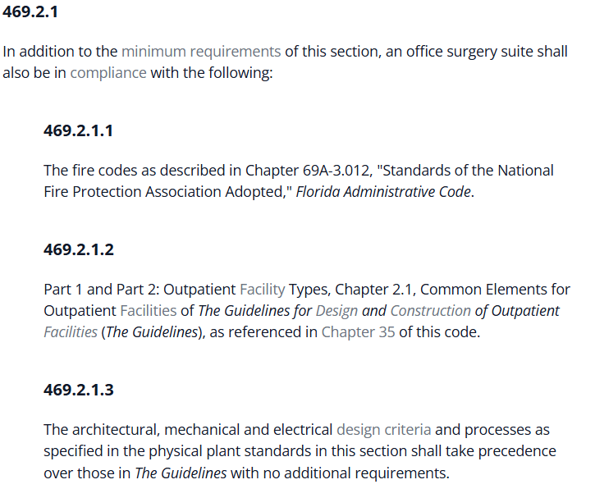

  - Fire Plans for Business Occupancy
    - The Codes & Standards Committee continues to discuss the growing complexity of outpatient procedure spaces located within business occupancies.
    - Many medical office buildings do not meet the same life safety and defend-in-place requirements as ambulatory healthcare occupancies, resulting in a full evacuation response during fire alarm activation.
    - Questions have been raised regarding procedure rooms where patients may not be under deep sedation or general anesthesia, but may still be in vulnerable conditions that limit their ability to self-preserve.
    - While current occupancy classifications often focus on the number of patients incapable of self-preservation due to anesthesia, the committee is exploring whether this framework fully captures the operational realities and patient risks associated with modern outpatient care environments.

  - Florida Fire Marshals and Inspectors Association – Code Interpretations
    - https://www.ffmia.org/Past-Interpretations
    - FFMIA Informal Interpretation — Exit Stair FCUs
      - https://www.ffmia.org/resources/Documents/informal%20interpretations/Penetrations.pdf
    - No interpretations submitted since last report

- Old Business
  - AA / FDOT Heliport Update - AC_150_5390_2D_Heliports.pdf
      - The FAA has replaced AC 150/5390-2C (2012) with AC 150/5390-2D, Heliport Design (January 2023), which now governs hospital heliport requirements.
      - The updated circular maintains the same compliance horizon, July 1, 2030, for hospitals classified as “private airports of public interest.”
      - FDOT has not yet finalized implementation details, so facilities should continue gathering heliport data, reviewing approach/departure surfaces per the new AC, and planning future capital needs.
      - FHEA should issue member guidance once FDOT releases its process.
    - Code Guidance Request
        - Pillow Speaker Initial and ongoing testing requirements
        - Vegetation ground cover near buildings

3. Federal / Florida Life Safety Code Adoption
- Florida adopted NFPA 101-2021 as part of the Florida Fire Prevention Code, effective December 31, 2023.
- Under Chapter 633.202, Florida Statutes, the Florida State Fire Marshal updates the code on a three-year cycle. The 2024 edition is expected to become effective December 31, 2026, pending rulemaking.
Standard | CMS, TJC, DNV | AHCA as of 01/01/2024 | Publication Name
NFPA 101 | 2012 | 2021 | Life Safety
NFPA 10 | 2010 | 2018 | Standard for portable fire extinguishers
NFPA 17 | 2009 | 2021 | Standard for dry chemical extinguishing systems
NFPA 17A | 2009 | 2021 | Standard for wet chemical extinguishing systems
NFPA 25 | 2011 | 2020 | Standard for the inspection, testing, and maint of water-based fire protection systems
NFPA 70 | 2011 | 2020 | NEC
NFPA 72 | 2010 | 2019 | National Fire Alarm and signaling code
NFPA 80 | 2010 | 2019 | Standard for Fire Doors and other opening protectives
NFPA 90A | 2012 | 2021 | Standard for the installation of AC and Ventilation Systems
NFPA 96 | 2011 | 2021 | Standard for Ventilation control and Fire Protection of commercial Cooking Operations
NFPA 99 | 2012 | 2021 | Health Care Facilities Code
Florida Building Code |  | 2023 | 8th Edition
FGI Guidelines |  | 2022 | https://fgiguidelines.org/guidelines/adoption-map/

Exhibit A
FHEA Codes & Standards Committee – Charter

Purpose
The FHEA Codes & Standards Committee supports the mission of the Florida Healthcare Engineering Association by serving as a trusted, educational resource for the interpretation and application of codes, standards, and regulatory requirements impacting healthcare facilities in Florida.
The committee exists to educate, clarify, and elevate understanding, helping healthcare engineering professionals navigate complexity, reduce risk, and support safe, compliant environments of care.

Alignment with FHEA Mission & Values
The committee advances FHEA’s core values by:
- Promoting education and professional development
- Encouraging collaboration across disciplines
- Providing objective, credible guidance

Scope
The committee focuses on healthcare-related codes and standards, including:
- NFPA codes and standards
- Florida Building Code (FBC)
- Florida Fire Prevention Code
- CMS and accreditation-related requirements (TJC, DNV, etc.)
Primary activities include:
- Interpreting code intent and practical application
- Translating complex requirements into usable guidance
- Identifying and communicating emerging code changes
- Supporting FHEA education through presentations, webinars, and conference content
- Facilitating informed discussion of real-world challenges faced by healthcare facilities

Committee Composition
The committee is multidisciplinary and may include both active and supporting members.
Leadership & Responsibilities
Chair
- Sets direction and priorities
- Coordinates meetings and agendas
- Serves as liaison to FHEA leadership
- Ensures alignment with FHEA mission and ethics
Members
- Contribute subject-matter expertise
- Support educational initiatives and content, engaging collaboratively and objectively

Meeting Cadence
- Bi-monthly meetings, with additional sessions as needed to support education and FHEA events

